INTERNAL QUALITY ASSURANCE CELL
&
DEPARTMENT OF BIOMEDICAL ENGINEERING

Ref: SEC/BME/2024-25/01 Date: 14.04.2025

CIRCULAR

Date: 16ᵗʰ & 17ᵗʰ April 2025

Time: 10.00AM to 4.00PM

Venue: Seminar Hall

HoD PRINCIPAL

Copy to
- All HoD’s
- Notice board
- To be read in all class rooms

DEPARTMENT OF BIOMEDICAL ENGINEERING
REPORT OF THE EVENT

Name of the activity :
Department :
Academic year :
Date of activity conducted :
.

Workshop Overview

Day 1: Fundamentals and Demonstrations

Session Highlights

Key Takeaways

Day 2: Advanced Troubleshooting and Maintenance
Session Highlights
Practical Sessions

Learning Outcomes

Conclusion

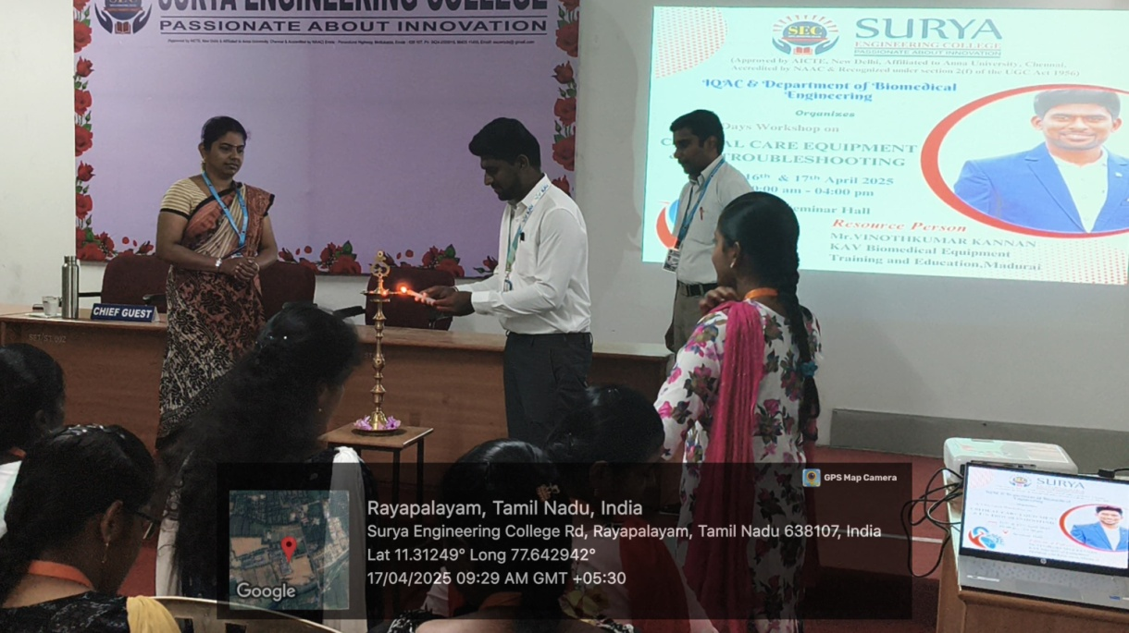
Function was inaugurated by our resource person
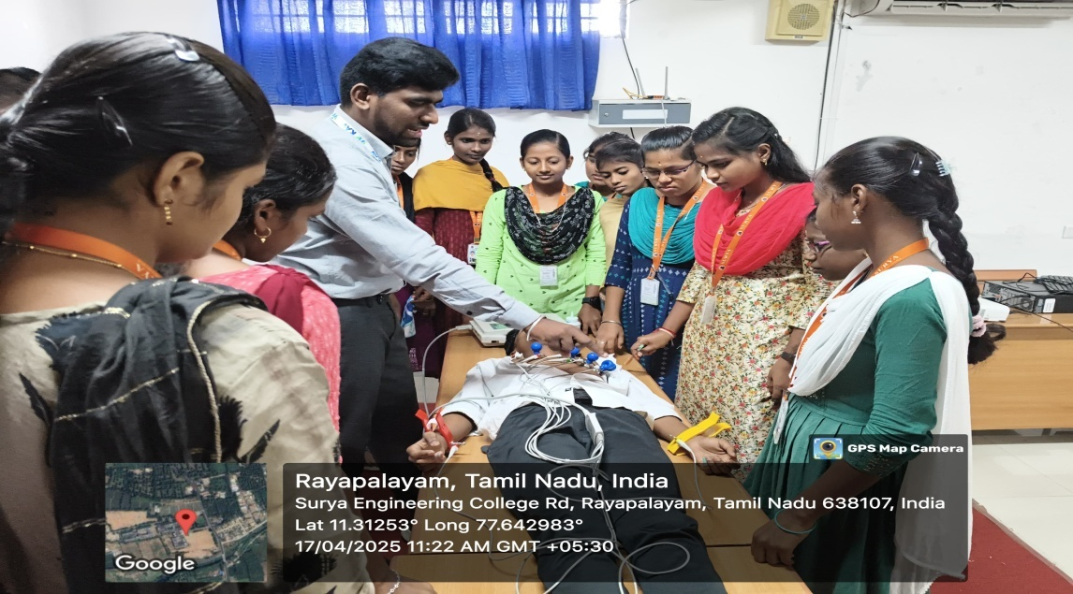
Students practicing in the practical session of the workshop

HoD PRINCIPAL

